Exercise 1: Configuring a Basic Spring Application

Scenario: Your company is developing a web application for managing a library. You need to use the Spring Framework to handle the backend operations.
Steps:
1. Set Up a Spring Project:
- Create a Maven project named LibraryManagement.
- Add Spring Core dependencies in the pom.xml file.
2. Configure the Application Context:
- Create an XML configuration file named applicationContext.xml in the src/main/resources directory.
- Define beans for BookService and BookRepository in the XML file.
3. Define Service and Repository Classes:
- Create a package com.library.service and add a class BookService.
- Create a package com.library.repository and add a class BookRepository.
4. Run the Application:
- Create a main class to load the Spring context and test the configuration.
IMPLEMENTAION:
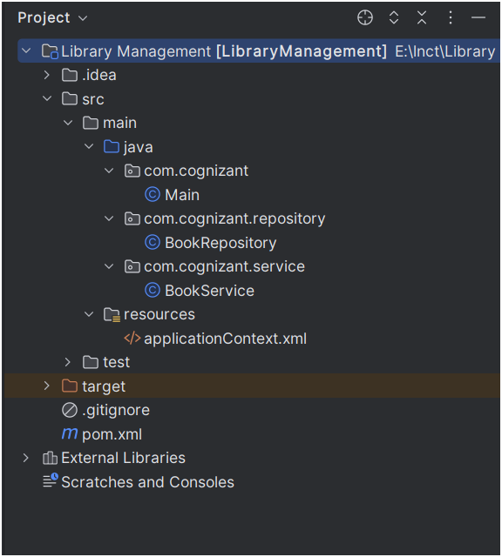
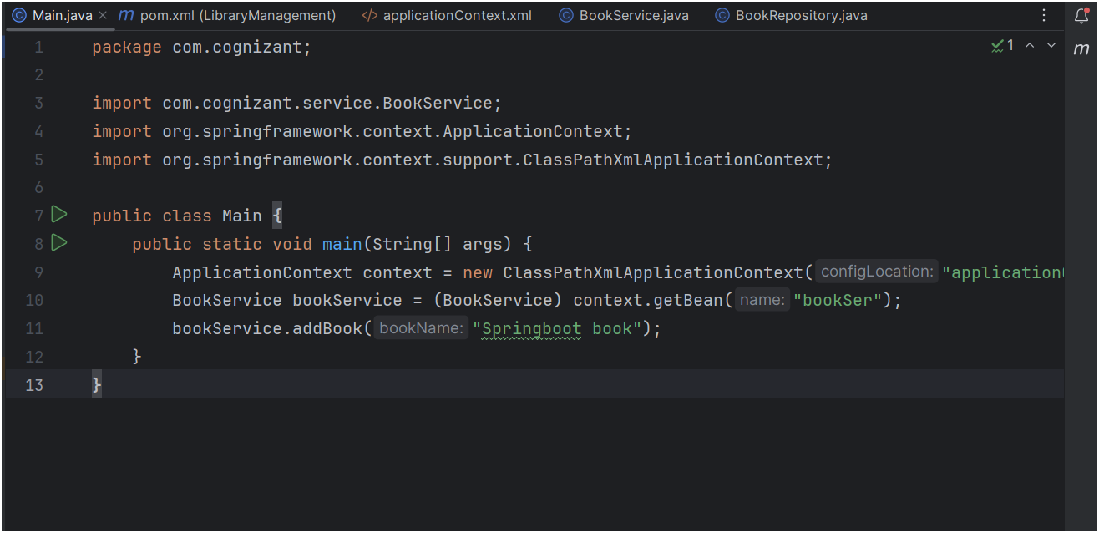
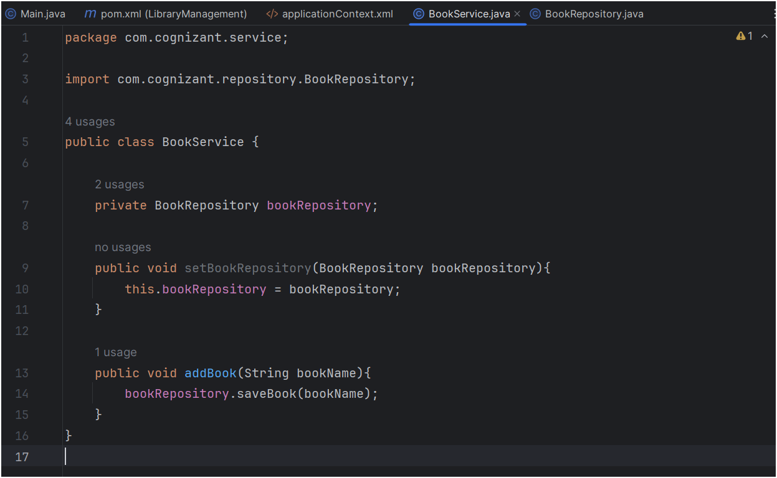

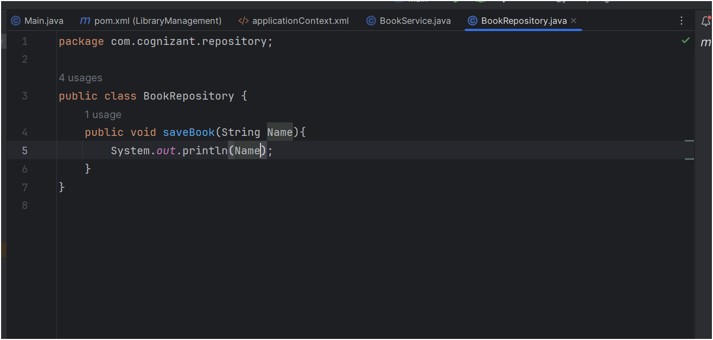
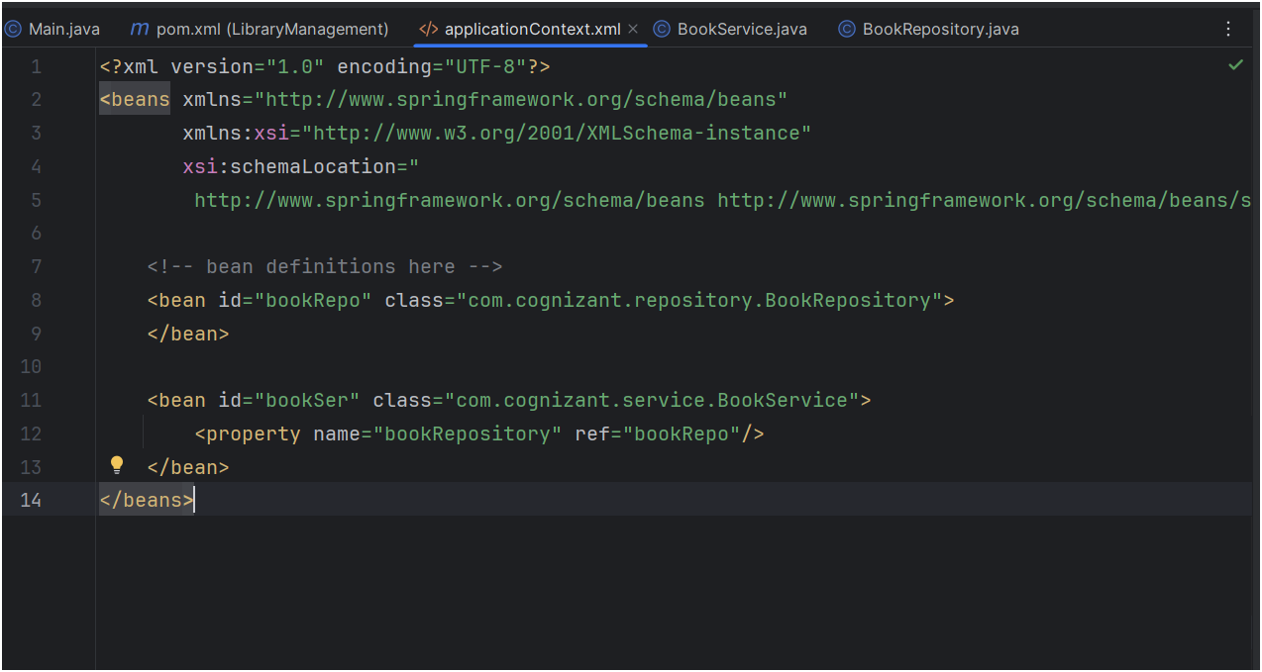
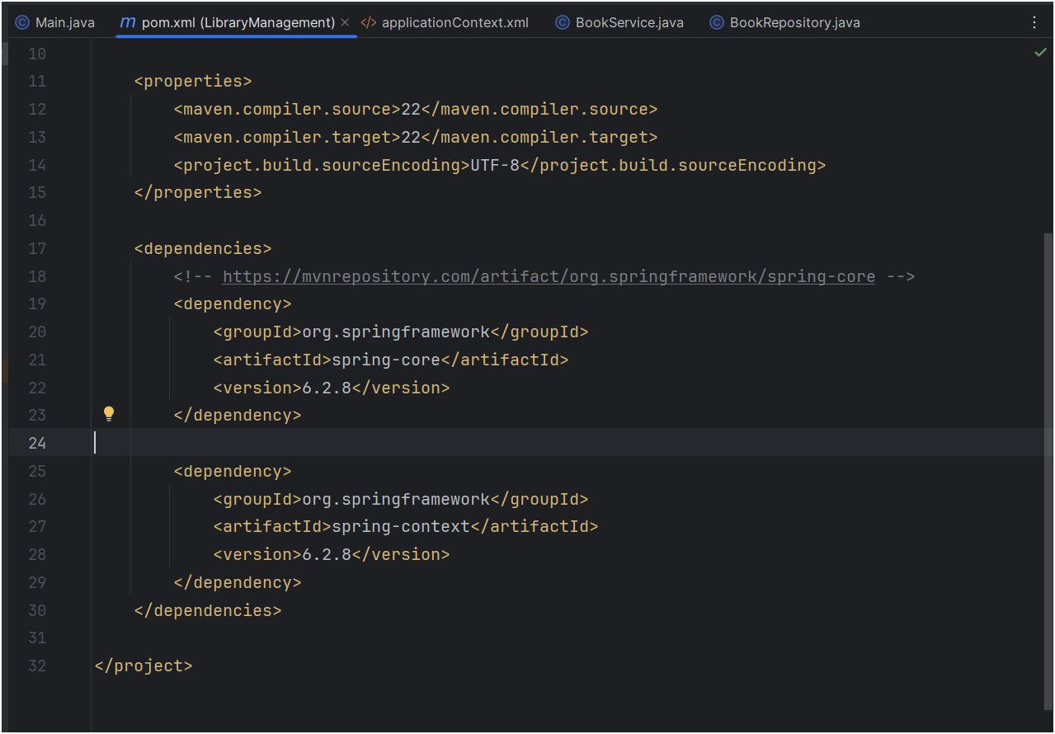
OUTPUT :
